THE FITNESS FREAKZZ (GYM WEBSITE)
A
MINI PROJECT REPORT
BACHELOR OF ENGINEERING
IN
CSE(ARTIFICIAL INTELLIGENCE & DATA SCIENCE)
BY GROUP
160521747021 MOHAMMED AMIR UR RAHMAN
160521747035 MOHAMMED HAMED HUSSAIN AWAD
160521747027 MOHAMMED MOHSIN UDDIN
160521747011 MOHAMMED YOUSUF
UNDER THE ESTEEMED GUIDANCE OF
Mrs. HEENA YASMIN
(ASST.PROFESSOR)





CERTIFICATE
____________________________________________________________________________________
This is to certify that the project work entitled – “FITNESS FREAKZZ (GYM WEBSITE) USING HTML, CSS AND JAVASCRIPT” is a bonafide work of MOHAMMED AMIR UR RAHMAN, MOHAMMED HAMED HUSSAIN AWAD, MOHAMMED MOHSIN UDDIN, MOHAMMED YOUSUF. Bearing H.T. No’s. 160521747021, 160521747035, 160521747027, 160521747011. Submitted in partial fulfillment of requirement for the award of the degree of BACHELOR OF ENGINEERING in Artificial Intelligence & Data Science during the academic year 2023-2024.
This is further certified that the work done under the guidance and the results of this work have not been submitted elsewhere for the award of the degree.

Internal Guide External Examiner

Head of the Department Principal
Acknowledgement
I express my sincere thanks to Mrs. HEENA YASMIN ,who has always been a great source of inspiration and giving me an opportunity to undertake this project also for encouraging and enlightening me on various aspects of my project work.
I am grateful to the entire faculty for their valuable guidance for successful completion of this project work.
I would also like to thanks all my classmates who have extended their cooperation and guided during my project work.

TABLE OF CONTENTS

CHAPTER NO | TITLE | PAGE NO
1 | ABSTRACT | 5
2 | INTRODUCTION | 6
3 | LITERATURE SURVEY | 7-8
4 | SYSTEM ARCHITECTURE | 9-10
5 | IMPLEMENTATION | 11-12
6 | PROJECT DESCRIPTION  6.1. GENERAL  6.2. METHODOLOGIES  6.3. MODULES  6.4. MODULES DESCRIPTION  6.5. TECHNIQUE USED | 13-17
7 | SNAPSHOTS | 18-19
8 | CONCLUSION | 20
9 | FUTURE ENHANCEMENT | 21-22

Abstract
This HTML document represents a webpage designed for Fitness Freakzz, a website focused on promoting fitness and providing resources for various workout routines. The webpage features a structured layout comprising a header, video background, main content section, and footer.
- Header Section:
  - The header contains a navigation bar with links to different sections of the website, including workouts, sports, care, yoga, and a store. Additionally, there's a login button for user authentication.
- Video Background:
  - A video background is incorporated into the webpage, set to auto play and loop with muted audio. This feature enhances the visual appeal and engagement of the site.
- Main Content Section:
  - The main content section showcases a centered heading emphasizing the brand "FITNESS FREAKZZ" and a subheading that conveys the website's dedication to promoting fitness as a worthwhile pursuit.
- Workout Categories:
  - The webpage offers various workout categories, presented as clickable boxes within a container. Each category box includes an image representing the workout type and descriptive text, providing users with quick access to different exercise routines.
- Footer Section:
  - The footer section completes the webpage, featuring horizontal rules for visual separation, a list containing website information such as FFTZZ and copyright details, and another horizontal rule for additional delineation.
In summary, this webpage serves as a comprehensive platform for fitness enthusiasts, offering diverse workout options and essential information in a visually appealing and user-friendly manner.

Introduction:
The provided HTML code encapsulates the foundation of a dynamic and visually engaging webpage tailored for Fitness Freakzz, a digital platform dedicated to promoting health and fitness. With its meticulously crafted structure and thoughtful design elements, this webpage aims to captivate users, providing them with a seamless experience as they navigate through its diverse offerings.
Upon landing on the Fitness Freakzz website, visitors are greeted by a sleek and intuitive interface, starting with a robust header section that features a streamlined navigation bar. This navigation bar serves as a gateway to various sections of the website, including curetted workouts, sports-related content, wellness resources, yoga practices, and a dedicated store for fitness essentials. Additionally, users are presented with a convenient login option, ensuring personalized access to exclusive features and content.
As users delve deeper into the website, they are greeted by a captivating video background that sets the tone for the fitness-centric atmosphere. This dynamic visual element not only enhances the aesthetic appeal of the webpage but also instills a sense of vitality and energy, reflecting the overarching theme of physical well-being and vitality.
Central to the Fitness Freakzz experience is its commitment to offering a diverse array of workout options tailored to meet the needs and preferences of users at every fitness level. The main content section showcases a compelling heading, boldly proclaiming the brand's identity as "FITNESS FREAKZZ," accompanied by a motivating subheading that underscores the value of embracing a proactive approach to health and fitness.
Moreover, the webpage presents users with a curetted selection of workout categories, each represented by visually striking and interactive boxes. From bodybuilding and cross fit to calisthenics, power lifting, and yoga, these categories offer users a comprehensive range of exercise routines to explore and engage with, fostering a sense of empowerment and agency in their fitness journey.
Finally, the webpage is rounded off with a polished footer section, providing users with essential information about Fitness Freakzz, including copyright details and acknowledgments. Through its cohesive design and user-centric approach, this webpage stands as a testament to Fitness Freakzz's unwavering commitment to promoting holistic health and well-being in an increasingly digital age.

LITERATURE SURVEY
A literature survey of the provided HTML code, which represents a webpage for Fitness Freakzz, a fitness-oriented platform, can explore various aspects of web development, design principles, and user experience considerations. Here's a breakdown of the literature survey based on different areas:
1. **HTML and CSS Development**:
- **HTML5 and CSS3**: The code utilizes modern HTML5 markup and CSS3 styling techniques to structure and design the webpage, showcasing familiarity with contemporary web development standards.
- **Responsive Design**: The inclusion of the viewport meta tag and responsive design practices demonstrate an understanding of creating websites that adapt well to different screen sizes and devices.
- **Semantic HTML**: Proper use of semantic HTML elements, such as `<header>`, `<nav>`, `<footer>`, and `<video>`, reflects adherence to best practices for accessibility, search engine optimization (SEO), and overall code maintainability.
2. **Web Design Principles**:
- **Visual Hierarchy**: The webpage employs a clear visual hierarchy with prominent headings, descriptive text, and visually appealing images to guide users' attention and engagement.
- **Color and Typography**: The choice of colors and typography enhances the overall aesthetic appeal and readability of the webpage, contributing to a cohesive and engaging user experience.
- **Whitespace and Layout**: Effective use of whitespace and a well-structured layout contribute to a visually balanced and organized design, facilitating easy navigation and comprehension for users.
3. **User Experience (UX)**:
- **Navigation Design**: The navigation bar provides intuitive access to different sections of the website, ensuring a seamless browsing experience for users.
- **Interactive Elements**: The use of interactive elements, such as clickable workout category boxes and a login button, enhances user engagement and interactivity, promoting a sense of agency and exploration.
- **Visual Stimulus**: Incorporating a video background adds a dynamic visual element that captures users' attention and creates an immersive browsing experience, fostering a connection with the brand and its message.

4. **Accessibility and SEO**:
- **Alt Attributes**: Proper use of `alt` attributes for images improves accessibility for users with visual impairments and contributes to better search engine indexing and ranking.
- **Semantic Markup**: Semantic HTML elements contribute to improved accessibility and SEO by providing clear structure and meaning to webpage content, facilitating easier interpretation by assistive technologies and search engine crawlers.
5. **Branding and Messaging**:
- **Brand Identity**: The consistent use of branding elements, such as the Fitness Freakzz logo and brand colors, reinforces the website's identity and fosters brand recognition among users.
- **Messaging and Tone**: The choice of language and messaging conveys the brand's values and mission, emphasizing the importance of fitness and well-being in an engaging and motivational manner.
By analyzing these aspects, a literature survey can provide insights into the effective utilization of web development technologies, design principles, and UX considerations in creating a compelling and user-friendly webpage like Fitness Freakzz. Additionally, it can highlight best practices and emerging trends in web development and design that contribute to an enhanced online experience for users.

System Architecture
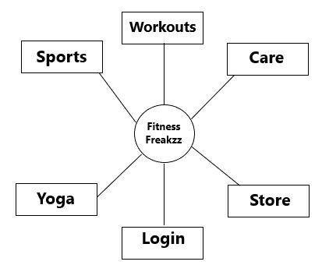
Main Page Diagram
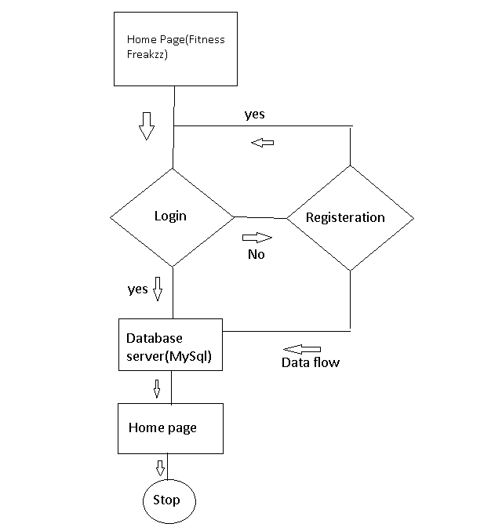
Login Page Diagram
Classification | Existing System | Propose System
- Main Page Features | Navigation bar, background color, Main page description | Navigation bar, background Video, Main Page Description, Footer-Copy right
- Navigation Bar | Workouts, Sports, Login | Workouts, Sports, Care, Yoga, Stores, Login
- Programming Languages | HTML, CSS | HTML, CSS, JAVASCRIPTS AND MY SQL.
- Workouts features | Description of different Workouts With Images | Description of different Workouts With Hyperlink connecting to the videos and description of major Workouts in Different Categories
- Login Page | Basic Login page consist of only html tags | Login page consist of Html Tags ,CSS and Data base connectivity

The system architecture for the Fitness Freakzz website involves several components that work together to deliver the desired functionality and user experience. Here's an overview of the system architecture:
1. **Client-Side Components**:
- **HTML/CSS**: The frontend structure and styling of the website are defined using HTML and CSS. HTML provides the markup for content structure, while CSS handles the presentation and styling aspects, ensuring a visually appealing layout and design.
- **JavaScript**: Client-side scripting with JavaScript can be used to add interactivity and dynamic behavior to the webpage. This may include features like interactive navigation elements, form validation, or dynamic content updates.
2. **Content Delivery Network (CDN) **:
- A CDN may be employed to optimize the delivery of static assets such as images, videos, and CSS files. By caching content on servers distributed across various geographic locations, a CDN helps reduce latency and improve website performance, especially for users accessing the site from different regions.
3. **Third-Party Integrations**:
- The website may integrate with third-party services or APIs to enhance functionality. For example, integrating with a payment gateway for online transactions in the store section, embedding videos from platforms like YouTube for workout demonstrations, or integrating social media sharing features to encourage user engagement and promotion.
4. **Security Measures**:
- Security measures such as HTTPS encryption, input validation, authentication mechanisms (e.g., OAuth, JWT), and protection against common web vulnerabilities (e.g., Cross-Site Scripting, SQL Injection) are implemented to safeguard user data and ensure the integrity and confidentiality of website transactions.
5. **Monitoring and Analytics**:
- Tools for monitoring website performance, user interactions, and traffic analytics (e.g., Google Analytics) may be employed to gather insights into user behavior, track website metrics, and make informed decisions for optimizing the website's effectiveness and user experience over time.
6. **Deployment and Scalability**:
- The website is deployed on a scalable infrastructure that can accommodate fluctuations in traffic and user demand. Cloud platforms like AWS, Azure, or Google Cloud provide scalable hosting solutions, allowing the website to dynamically allocate resources and scale horizontally or vertically as needed to handle varying loads.

Implementation
Implementing the Fitness Freakzz website involves translating the provided HTML code into a functional web application using appropriate technologies and tools. Here's a step-by-step guide for implementing the website:
1. **Setup Development Environment**:
- Install a text editor or integrated development environment (IDE) such as Visual Studio Code, Sublime Text, or Atom for writing code.
- Install Node.js and NPM (Node Package Manager) to manage dependencies and run JavaScript-based server-side code.
2. **Create Project Structure**:
- Set up a project directory for the website and organize files accordingly. Create separate folders for HTML, CSS, JavaScript, and other assets.
- Create subfolders within the project directory for images, videos, and any other static resources used on the website.
3. **HTML Structure**:
- Copy the provided HTML code into an `index.html` file within the HTML folder.
- Update file paths for images, videos, and other static assets to reflect the correct directory structure.
- Ensure that HTML markup is valid and semantic, adhering to best practices for accessibility and SEO.
4. **CSS Styling**:
- Create a `style.css` file within the CSS folder to contain custom styles for the website.
- Copy relevant CSS rules from the provided code or write new styles to achieve the desired layout, typography, colors, and visual effects.
5. **JavaScript Functionality**:
- If needed, create a `script.js` file within the JavaScript folder to include client-side scripting for interactive elements or dynamic behavior.
- Implement JavaScript code for any client-side functionality such as form validation, navigation menu toggling, or slideshow functionality.

6. **Server-Side Logic**:
- Install the Express.js framework using npm by running `npm install express` in the terminal within the project directory.Create a `server.js` file to define server-side logic using Express.js.
- Implement routes for serving static files (HTML, CSS, JavaScript, images, videos) and handling dynamic content or API requests if applicable.
7. **Database Integration** (if applicable):
- Choose a suitable database system (e.g., MongoDB, MySQL) and set up a database instance.
- Install database drivers or ORM libraries as needed and establish a connection to the database from the server-side code.
- Implement database schemas, models, and CRUD operations to store and retrieve data as required by the website.
8. **Deployment and Hosting**:
- Choose a cloud hosting provider (e.g., AWS, Azure, Heroku) and deploy the web application to a production environment. Configure domain settings and DNS records to point to the deployed application.
- Set up SSL/TLS certificates for HTTPS encryption and secure communication between the server and clients.
9. **Testing and Debugging**:
- Test the website functionality across different browsers and devices to ensure compatibility and responsiveness. Use browser developer tools and debugging techniques to identify and fix any issues or errors in the code.
- Implement unit tests, integration tests, or end-to-end tests as necessary to validate the website's functionality and performance.
10. **Monitoring and Maintenance**:
- Set up monitoring tools and alerts to track website performance, uptime, and user interactions.
- Regularly update dependencies, patches, and security configurations to keep the website secure and up-to-date. Monitor user feedback and analytics data to identify areas for improvement and optimization
By following these implementation steps, you can successfully develop and deploy the FitnessFreakzz website, providing users with a compelling and interactive platform for exploring fitness-related content and resources.
**Project Description
**General Description:**
The Fitness Freakzz website is a comprehensive online platform dedicated to promoting fitness, providing workout routines, sports-related content, wellness resources, yoga practices, and a store for fitness essentials. The website aims to inspire and guide users on their fitness journey by offering diverse workout options, valuable information, and a supportive community environment.

**Methodologies:**
1. **Agile Development:** The project follows an Agile development methodology, allowing for iterative development, continuous feedback, and incremental improvements based on user needs and market trends.
2. **User-Centric Design:** The website is designed with a focus on user experience (UX), ensuring intuitive navigation, engaging content presentation, and accessibility features to accommodate users of all abilities.
3. **Responsive Design:** Employing responsive design principles ensures that the website adapts seamlessly to various devices and screen sizes, providing a consistent experience across desktops, laptops, tablets, and smartphones.
4. **Iterative Testing:** Regular usability testing and feedback sessions are conducted to identify usability issues, gather user feedback, and iterate on design and functionality improvements.

**Modules:**
1. **Navigation Module:** Provides intuitive navigation through a menu bar with links to different sections of the website, including workouts, sports, care, yoga, and the store.
2. **Workout Categories Module:** Displays various workout categories, each represented by clickable boxes containing images and descriptive text. Users can explore different workout options and access instructional videos for each category.
3. **Video Background Module:** Enhances the visual appeal of the website with a dynamic video background, setting the tone for a fitness-oriented atmosphere.
4. **User Authentication Module:** Allows users to create accounts, log in, and access personalized features such as saved workouts, progress tracking, and community interaction.
5. **Content Management Module:** Facilitates the management and organization of website content, including blog posts, workout routines, product listings, and user-generated content.
6. **E-commerce Module:** Enables users to browse, search, and purchase fitness-related products from the online store, with features for product categorization, reviews, and secure payment processing.
7. **Community Interaction Module:** Fosters community engagement and interaction through forums, social media integration, and user-generated content sharing.

Techniques Used:
1. **HTML5/CSS3:** Utilized for structuring and styling the website layout, ensuring semantic markup and visually appealing design.
2. **JavaScript/ES6:** Implemented for client-side scripting to add interactivity, dynamic behavior, and form validation functionalities.
4. **MongoDB:** Used as the database system for storing and managing website data, including user profiles, workout routines, product listings, and user-generated content.
5. **Responsive Web Design:** Applied to ensure optimal viewing and interaction experience across a wide range of devices, from desktop computers to mobile devices.
6. **Secure Socket Layer (SSL)/Transport Layer Security (TLS):** Implemented to secure data transmission and protect user privacy through HTTPS encryption.
7. **Content Delivery Network (CDN):** Utilized to optimize content delivery, reduce latency, and improve website performance by caching static assets and distributing them across geographically dispersed servers.
8. **User Authentication and Authorization:** Implemented using techniques such as JSON Web Tokens (JWT) or OAuth for secure user authentication and authorization, enabling access control and personalized user experiences.
9. **Continuous Integration/Continuous Deployment (CI/CD):** Employed CI/CD pipelines for automated testing, code deployment, and version control management, ensuring efficient development workflows and rapid deployment of new features and updates.

Features:-
The provided HTML code for the FitnessFreakzz website encompasses several features that contribute to its functionality, interactivity, and user experience. Here are the key features highlighted:
1. **Navigation Bar**:
- Provides easy access to different sections of the website such as workouts, sports, care, yoga, and the store.
- Enhances user navigation and allows for seamless exploration of the website's content.
2. **Video Background**:
- Adds visual appeal and creates an immersive experience for users visiting the website.
- Sets the tone for a fitness-oriented atmosphere, engaging visitors from the moment they land on the page.
3. **Workout Categories**:
- Presents various workout categories such as bodybuilding, crossfit, calisthenics, powerlifting, and yoga.
- Each category is represented by a clickable box containing an image and descriptive text.
- Allows users to explore different types of workouts and access instructional videos for each category.
4. **Responsive Design**:
- Ensures that the website layout and content adapt seamlessly to different screen sizes and devices.
- Provides a consistent and optimized user experience across desktops, laptops, tablets, and smart phones.
5. **User Authentication Button**:
- Offers a login button for users to access personalized features such as saved workouts, progress tracking, and community interaction.
- Enhances user engagement and allows for a more customized experience based on user preferences and history.

6. **Footer Section**:
- Contains copyright information and acknowledgments, providing necessary legal and branding details.
- Offers a visually appealing conclusion to the webpage and reinforces the website's identity and professionalism.
7. **Interactive Elements**:
- Incorporates hover effects on buttons to enhance visual feedback and user interaction.
- Adds a dynamic and engaging element to the website, inviting users to explore further.
8. **SEO-Friendly Markup**:
- Utilizes semantic HTML elements and descriptive text to improve search engine visibility and ranking.
- Enhances the website's discoverability and accessibility for users searching for fitness-related content online.
9. **Visual Styling**:
- Applies consistent and visually appealing styles to elements such as headings, text, images, and buttons.
- Creates a cohesive and aesthetically pleasing design that reflects the brand identity and message of Fitness Freakzz.
10. **Accessibility Considerations**:
- Implements alt attributes for images to ensure compatibility with screen readers and improve accessibility for users with disabilities.
- Adheres to best practices for accessibility, making the website inclusive and usable for all visitors.
These features collectively contribute to creating an engaging, informative, and user-friendly website experience for visitors to FitnessFreakzz, fostering a sense of connection, motivation, and empowerment in their fitness journey.

Project Scope: Fitness Freakzz Website Development
1. **Background:**
The Fitness Freakzz website aims to provide information and resources related to fitness, including various fitness activities, sports, care routines, and a store for related products. The website targets fitness enthusiasts and individuals interested in leading a healthy lifestyle.
2. **Goals:**
- Create an engaging and user-friendly website interface.
- Provide comprehensive information about fitness activities, sports, care routines, and related products.
- Allow users to explore different fitness categories and access resources such as videos, articles, and product listings.
- Facilitate user interaction through navigation, links, and visually appealing design elements.
- Encourage user engagement and retention through informative content and seamless browsing experience.
3. **Features:**
- **Navigation Menu:**
- Main navigation menu with links to different sections of the website (e.g., Fitness, Sports, Care, Yoga, Store).
- Dropdown menus for subcategories (e.g., different sports types under Sports, various care routines under Care).
- Homepage:
- Dynamic background video or image showcasing fitness-related activities.
- Introduction to Fitness Freakzz brand and its mission.
- Highlights of popular fitness categories and products.

- **Fitness Categories:**
- Detailed pages for each fitness category (e.g., Bodybuilding, Crossfit, Yoga).
- Information about the category, including benefits, techniques, and tips.
- Links to relevant resources such as videos, articles, and recommended products.
- **Store:**
- Product listings for fitness-related products (e.g., workout equipment, supplements)
- Product details, including descriptions, images, prices, and customer reviews.
- Shopping cart functionality for adding and purchasing products.
- **Footer:**
- Contact information for Fitness Freakzz.
- Social media links for sharing and following.
4. **Technical Requirements:**
- HTML, CSS, and JavaScript for front-end development.
- Server-side scripting (e.g., PHP) for dynamic content and form submissions.
- Database (e.g., MySQL) for storing product information and user data (if applicable).
- Responsive design to ensure compatibility across various devices and screen sizes.
- Security measures to protect user data and prevent unauthorized access.
- SEO optimization for better visibility on search engines.
5. **Timeline:**
- Phase 1: Planning and Design (2 weeks)
- Phase 2: Front-end Development (4 weeks)
- Phase 3: Back-end Development and Integration (4 weeks)
- Phase 4: Testing and Quality Assurance (2 weeks)
- Phase 5: Deployment and Launch (1 week)

6. **Deliverables:**
- Functional website with all specified features and content.
- Source code and documentation for future maintenance and updates.
- User manual or guide for website administrators (if applicable).
- Training sessions for staff responsible for website management (if applicable).

7. **Budget:**
- The budget for the FitnessFreakzz website development project will depend on factors such as scope, complexity, and resources required.
- Budget allocation for design, development, testing, hosting, and ongoing maintenance should be considered.

8. **Stakeholders:**
- Project Manager: Responsible for overseeing the entire project and ensuring timely delivery.
- Development Team: Front-end and back-end developers, designers, and testers.
- Client Representatives: Provide input, feedback, and approvals throughout the project lifecycle.
- End Users: Individuals visiting the FitnessFreakzz website for fitness-related information and products.
9. **Risks and Challenges:**
- Technical challenges related to integration with third-party services (e.g., payment gateways for the online store).
- Ensuring data security and compliance with regulations (e.g., GDPR for user data protection).
- Meeting deadlines and managing scope changes during development.
- Addressing compatibility issues across different browsers and devices.
Snapshots:-
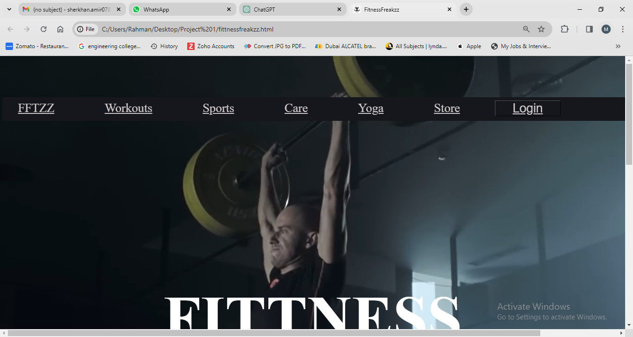
Fig 1 :Home Page
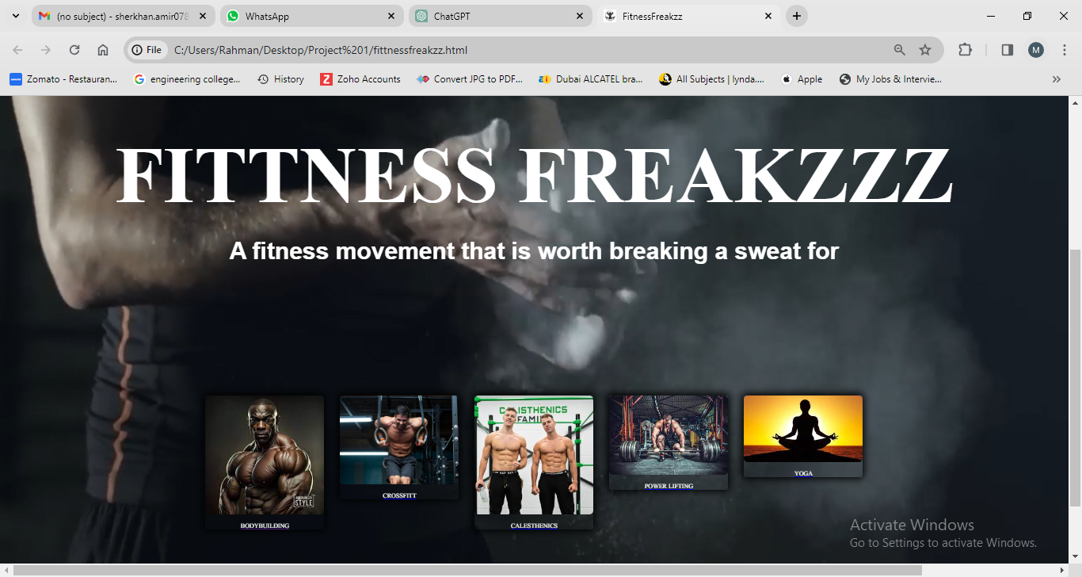
Fig2: Home Page(2)
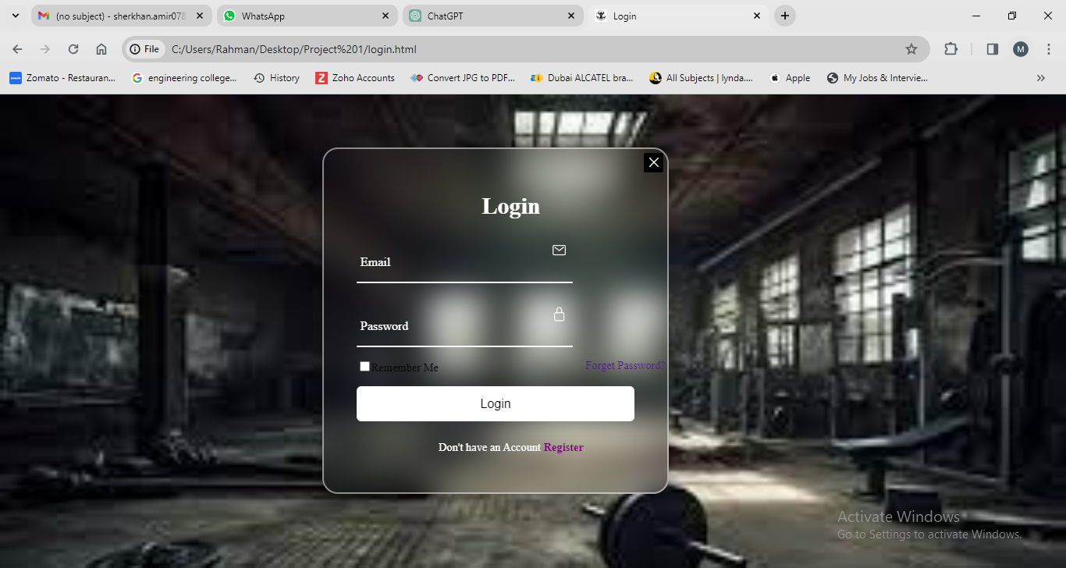
Fig 3: Login Page
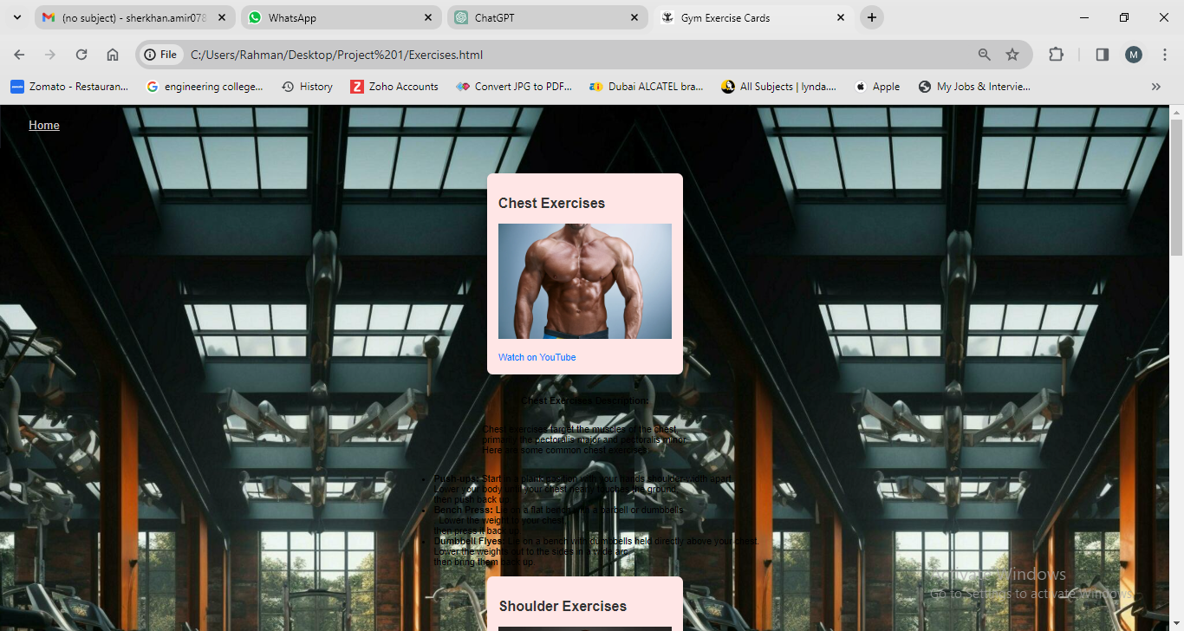
Fig 4 : Workout Page

**Conclusion:**
The Fitness Freakzz website presents a dynamic and visually appealing platform for fitness enthusiasts to explore various workout categories, access instructional videos, and engage with fitness-related content. With its intuitive navigation, immersive video background, and responsive design, the website aims to inspire and support users in their fitness journey.
By leveraging modern web development technologies and design principles, Fitness Freakzz provides a seamless and engaging user experience across different devices and screen sizes. The incorporation of interactive elements, user authentication features, and SEO-friendly markup enhances usability, accessibility, and discoverability, further enriching the website's value proposition.

**Future Enhancements:**
While the current version of Fitness Freakzz offers a solid foundation, there are several opportunities for future enhancements and expansions to enrich the user experience and extend the website's functionality:
1. **User Profiles and Social Integration:**
- Implement user profiles with features for tracking progress, setting fitness goals, and connecting with other users.
- Integrate social media sharing options to facilitate user-generated content sharing and community engagement.
2. **Personalized Recommendations:**
- Incorporate machine learning algorithms to analyze user preferences and behavior, providing personalized workout recommendations and content suggestions.
3. **Community Forums and Challenges:**
- Introduce community forums or discussion boards where users can share tips, advice, and success stories, fostering a sense of community and support.
- Organize fitness challenges or events to encourage user participation and motivation, with features for tracking progress and rewarding achievements.
4. **E-commerce Expansion:**
- Expand the e-commerce section to offer a wider range of fitness products, nutritional supplements, and merchandise.Implement features for user reviews, product recommendations, and personalized shopping experiences.
5. **Mobile App Development:**
- Develop a companion mobile app for FitnessFreakzz to provide on-the-go access to workouts, progress tracking, and community interaction.
- Utilize native mobile features such as push notifications, GPS tracking, and offline mode for enhanced user engagement.
6. **Content Diversification:**
- Diversify content offerings with additional workout categories, fitness articles, expert interviews, and multimedia resources.
- Collaborate with fitness professionals, influencers, and brands to create exclusive content and partnerships.
7. **Performance Optimization:**
- Continuously optimize website performance by minimizing load times, reducing server response times, and optimizing code and assets.
- Implement caching mechanisms, content delivery networks (CDNs), and server-side optimizations to enhance scalability and reliability.
By incorporating these future enhancements, Fitness Freakzz can evolve into a comprehensive and indispensable resource for fitness enthusiasts worldwide, empowering users to achieve their health and wellness goals with confidence and enthusiasm.
8. - Implementation of user accounts for personalized experiences and purchases.
- Integration with social media platforms for community engagement and sharing.
- Expansion of product offerings in the online store based on user demand and market trends.
- Regular updates and maintenance to keep the website content fresh and relevant.

REFERENCE WEBSITES
1. **Nike Training Club**: Nike's Training Club app offers a wide range of workouts, training plans, and expert guidance for users of all fitness levels. The website provides detailed information about the app's features, workout categories, and user testimonials.
Website: [Nike Training Club](https://www.nike.com/ntc-app)
2. **MyFitnessPal**: MyFitnessPal is a popular fitness and nutrition tracking app that helps users monitor their diet, exercise, and overall health. The website offers resources on healthy eating, exercise tips, and success stories, along with information about the app's features and subscription plans.
Website: [MyFitnessPal](https://www.myfitnesspal.com/)
3. **Bodybuilding.com**: Bodybuilding.com is an online community and resource hub for fitness enthusiasts, offering workout plans, articles, supplements, and forums for discussion. The website features comprehensive content on various fitness topics, along with tools for tracking progress and setting goals.
Website: [Bodybuilding.com](https://www.bodybuilding.com/)
4. **Fitbit**: Fitbit is a leading provider of wearable fitness trackers and smartwatches, helping users monitor their activity, sleep, and overall health. The website showcases Fitbit's products, features, and compatibility with third-party apps, along with resources on staying active and healthy.
Website: [Fitbit](https://www.fitbit.com/)
5. **Under Armour Map MyFitness**: Map My Fitness, owned by Under Armour, is a suite of fitness tracking apps for running, cycling, and other activities. The website offers information about the apps' features, training plans, and community challenges, along with articles on fitness and nutrition.
Website: [MapMyFitness](https://www.mapmyfitness.com/)
6. **CrossFit**: CrossFit is a high-intensity fitness program that combines functional movements with varied workouts. The website provides information about CrossFit's methodology, training programs, and affiliated gyms, along with resources for athletes and coaches.
Website: [CrossFit](https://www.crossfit.com/)
7. **Men's Health**: Men's Health is a lifestyle and fitness magazine offering articles, videos, and guides on exercise, nutrition, and wellness. The website features workouts, recipes, product reviews, and expert advice for men seeking to improve their health and fitness.
Website: [Men's Health](https://www.menshealth.com/)

